SmartCare v0.3 - Domain Model Workbook
Week 6 student resource
Prepared by: Mani (u3263841) | Week 6 | Version 0.3
This workbook turns the v0.2 requirements into a domain model. Every class, attribute and relationship below is traced to a requirement ID from v0.2. Where no requirement supports something, it has been left out and the reason recorded.

Requirement-to-Concept Trace
Requirement | Concept | State/behaviour | Decision
FR-01 — create a patient record with a unique ID, names and date of birth | Patient | State: patient_id, given_name, family_name, date_of_birth. Behaviour: created holding all four. | Becomes a class. It has identity that outlives any one appointment.
FR-02 — retrieve and display a patient by ID | Patient | Behaviour: report its own details. The lookup itself needs a collection of patients. | Patient kept. The lookup stays a plain dictionary in the application entry point for v0.3 — see MQ-01.
FR-03 — update stored patient details | Patient | Behaviour: update_details(). | Behaviour sits on Patient itself, not on a separate manager class.
FR-04 — create a practitioner with a unique ID, name and role | Practitioner | State: practitioner_id, name, role. | Becomes a class, for the same reason as Patient.
FR-05 — an appointment links exactly one patient and one practitioner to a date and start time | Appointment | State: patient, practitioner, date, start_time. | Becomes a class. Also fixes both associations at 1 on the Patient and Practitioner ends.
FR-06 — reject a booking that clashes with an existing Booked appointment | AppointmentBook | Behaviour: _has_clash() then book(). Needs to see every appointment at once. | This is what earns the fourth class. No single Appointment can see the others, so the rule has nowhere else to live.
FR-07 — status is one value from a fixed list | Appointment | State: status, constrained to BOOKED, COMPLETED, CANCELLED. | An attribute with an enumeration, not a Status class. It carries no behaviour of its own.
FR-08 — change the status of an existing appointment | Appointment | Behaviour: change_status(), rejecting any value outside the list. | Behaviour on Appointment, which keeps the rule next to the data it protects.
FR-09 — cancel by setting status to Cancelled and retain the record | Appointment | Behaviour: cancel(). | No Cancellation class. Cancelling is a state change on something that already exists.
FR-10 and FR-11 — list a patient’s history, and a practitioner’s day | AppointmentBook | Behaviour: for_patient() includes cancelled; for_practitioner_on() excludes them. | Both are queries across the whole collection, so both confirm AppointmentBook.
FR-12 — reschedule, re-running the clash check first | AppointmentBook and Appointment | Behaviour: book.reschedule() checks, then appointment.move_to() applies. | Split deliberately: the book owns the rule, the appointment owns its own data.
NFR-03 and NFR-05 — logic separate from the interface; nothing deleted, IDs never reused | All four classes | No printing or input anywhere in the classes. No delete or remove method is modelled at all. | A constraint on the model rather than a class. It is why AppointmentBook has no remove().

CRC Cards

Patient
Responsibilities | Collaborators
Know its own patient ID, given name, family name and date of birth (FR-01). | Appointment — holds a reference to the patient it belongs to (FR-05).
Update its own details when they change (FR-03). | AppointmentBook — asked for this patient’s history, rather than the patient keeping its own copy (FR-10).
Report a display name for confirmations and lists (FR-02, AC-01).
Never let its patient ID be changed once set (NFR-05).

Practitioner
Responsibilities | Collaborators
Know its own practitioner ID, name and role (FR-04). | Appointment — each appointment names exactly one practitioner (FR-05).
Report a display name for the booking confirmation (AC-01). | AppointmentBook — asked for this practitioner’s list for a date (FR-11).
Never let its practitioner ID be changed once set.

Appointment
Responsibilities | Collaborators
Know the one patient, one practitioner, date and start time it links (FR-05). | Patient and Practitioner — held as references, asked for display names.
Keep its status to one of Booked, Completed or Cancelled (FR-07). | AppointmentBook — creates it, and is the only thing allowed to approve a move (FR-06, FR-12).
Change its own status when asked (FR-08).
Cancel itself by setting status to Cancelled, never by deleting anything (FR-09, NFR-05).
Answer whether it clashes with a given practitioner, date and time (helps FR-06).
Move itself to a new date and time once the book has approved it (FR-12).

AppointmentBook (optional class)
Responsibilities | Collaborators
Hold every appointment, including cancelled ones (FR-09, NFR-05). | Appointment — creates and holds them.
Refuse to create an appointment that clashes with an existing Booked one (FR-06). | Patient and Practitioner — taken as arguments, never stored twice.
Create the appointment once the check passes (FR-05).
Return a patient’s appointments in date order, including cancelled (FR-10).
Return a practitioner’s appointments for a date, excluding cancelled (FR-11).
Re-run the clash check before allowing a reschedule (FR-12).

UML Class Diagram
Insert/draw UML here. Include defensible relationships and multiplicities.
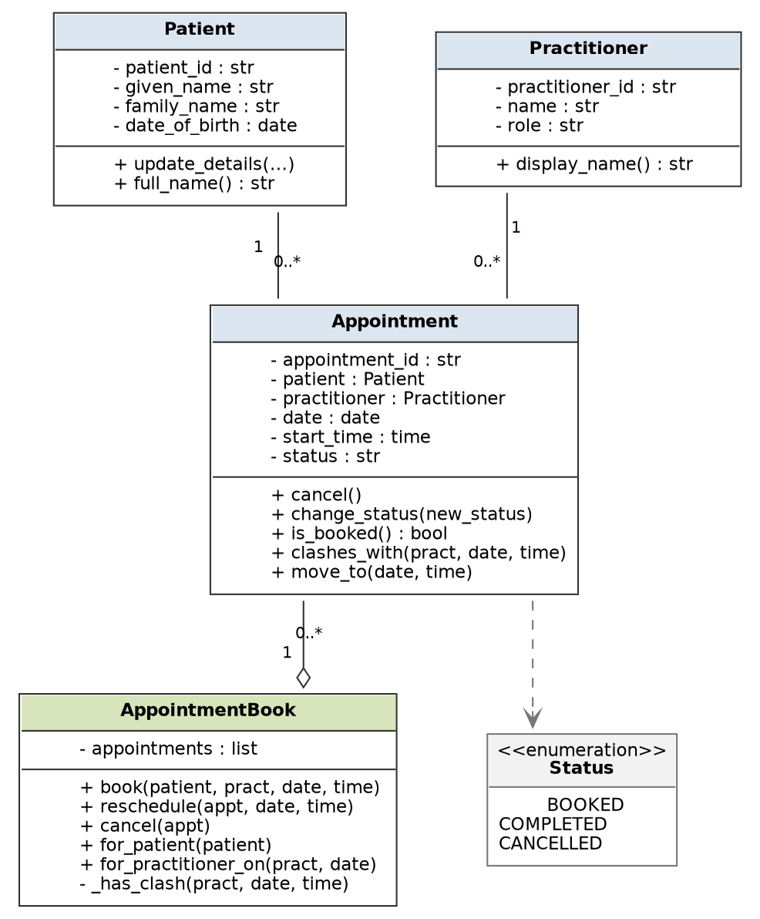
Figure 1 — SmartCare v0.3 domain model.
Reading the diagram:
- Patient 1 — 0..* Appointment and Practitioner 1 — 0..* Appointment. Both ends are 1 because FR-05 says an appointment links exactly one of each. Both are plain associations, not composition, because NFR-05 rules out deleting appointments when something else goes away.
- AppointmentBook has an open diamond (aggregation) to Appointment. The book holds the appointments and creates them, but they are not destroyed with it.
- The dashed arrow to the Status enumeration is a dependency, not an association. Status is a set of allowed values for an attribute (FR-07), not an object the appointment owns.
- FR-06 does not appear as a multiplicity anywhere. “One Booked appointment per practitioner per date and start time” is a business rule enforced in _has_clash(); writing 0..1 on the diagram would wrongly say a practitioner can only ever have one appointment.

Design Rationale
Explain class selection, responsibility allocation and key relationships.
Why these four classes
I started from the nouns in v0.2 and applied one test to each: does it have state worth storing, behaviour of its own, and an identity that persists? Patient, Practitioner and Appointment pass all three. Name and Status fail the identity and behaviour tests and became attributes. Database failed because it is a storage decision, not something the client ever mentioned. Cancellation failed because FR-09 already describes it as a status change on an appointment that continues to exist.
Clinic was the closest call. It reads naturally, but under assumption A-01 there is exactly one of them and it has no rule to enforce, so it would only be a container holding other containers. I left it out and recorded the reason rather than adding a class that does nothing.
Why AppointmentBook exists when the manager classes do not
The fourth class is the one I had to argue for. FR-06 has to compare a proposed booking against every other appointment, and FR-10, FR-11 and FR-12 are all questions about the whole collection. An individual Appointment cannot see its siblings, so that rule has nowhere to live unless something owns the collection.
That is the difference between AppointmentBook and the PatientManager the AI proposed. A manager that only wraps one object’s getters and setters leaves the object with no behaviour and adds a layer for nothing. A class that owns a collection and enforces a rule across it is doing real work. I used that test on all six AI proposals and only this one passed. I also renamed it, because “Manager” describes nothing — the name should say what it holds and which rule it protects.
How responsibilities were allocated
The rule I followed is that behaviour goes with the data it needs. Patient updates its own details because it holds them (FR-03). Appointment cancels itself and changes its own status because it holds the status (FR-08, FR-09). AppointmentBook does the clash check because it is the only thing that can see all the appointments (FR-06).
FR-12 is deliberately split across two classes. The book checks whether the new time is free, then asks the appointment to move itself. Neither class can do the whole job alone, and splitting it this way means the rule stays in one place while the data stays in another.
Keeping the model testable
NFR-03 and NFR-04 shaped the model as much as any functional requirement. None of the four classes prints anything or reads input, so the booking rules can be tested directly. There is no delete or remove method anywhere, which is NFR-05 expressed as an absence rather than a method — you cannot accidentally delete through an interface that has no way to do it.
Open modelling questions
- MQ-01: FR-02 needs a collection of patients to search. For v0.3 that is a plain dictionary in the application entry point, because there is no rule to enforce over it, unlike FR-06. If patient lookup later gains rules (merging duplicates, archiving), it earns a class of its own.
- MQ-02: OQ-03 from v0.2 is still open. If appointments turn out to vary in length, Appointment needs a duration attribute and _has_clash() has to compare overlapping ranges instead of matching exact start times. The model is written so that change lands in one method.
- MQ-03: OQ-04 and OQ-08 are still open. If the client wants to know who cancelled and when, those become two attributes on Appointment first. Only if cancellation grows rules of its own would it become a class.
- MQ-04: appointment_id is in the model but no v0.2 requirement asks for it. I included it because FR-08 and FR-09 need a way to name a specific appointment, and AC-03 refers to one as AP-0101. Flagging it as my inference rather than a stated requirement.

AI Design Review Record
AI suggestion | Evidence | Decision | Reason | Model change
Add PatientManager, PractitionerManager and AppointmentManager. | Part evidence — cited FR-06 for the third one only | Modified | The first two would only wrap getters and setters. The third names a real rule that spans every appointment. | Dropped two, kept one, renamed it AppointmentBook.
Model Status as a class with BookedStatus, CompletedStatus and CancelledStatus subclasses. | Cited FR-07, but over-read it | Rejected | FR-07 asks for one value from a fixed list. Subclasses would add four classes and a state machine for a field that never behaves differently. | None. Status stays an attribute backed by an enumeration.
Appointment should hold a list of patients so group sessions are supported. | No evidence — no requirement mentions group sessions | Rejected | FR-05 says exactly one patient. Changing 1 to 1..* would break AC-01 and make the FR-06 clash rule ambiguous. | None. Multiplicity stays at 1 on the Patient end.
Add a NotificationService so patients are told when an appointment changes. | No evidence — no requirement, and already out of scope | Rejected | Reminders were ruled out of scope in v0.2 and this is the second time a tool has suggested them. Repetition is not evidence. | None. Recorded here so the decision is not re-argued in Week 7.
Patient should own its own list of its appointments. | Evidence — correctly cited FR-10 | Modified | FR-10 is real, but holding the list on both Patient and AppointmentBook gives two copies that can drift apart. | FR-10 answered by AppointmentBook.for_patient(). Patient holds no list.
Appointment.cancel() should delete the record to keep the list small. | Contradicts FR-09 and NFR-05 | Rejected | This directly contradicts a stated requirement. It was the suggestion that most needed checking against the source rather than accepting because it sounded sensible. | None. cancel() only sets status, and no class has a delete method.

